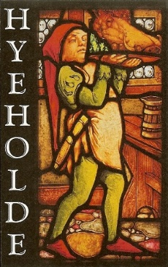

 

THANKSGIVING MENU
Thursday, November 23, 2023

 STARTER 

LOCAL CHEESE...$12.00/$16.00
Calkins Creamery cheese, breadsticks, apple chutney, Hyeholde honey

 SOUP or SALAD 

SHERRY BISQUE...$12.00
A Hyeholde tradition

AUTUMN SQUASH SOUP…$14.00
Toasted pepitas, roasted squash

ARTISAN GREENS...$14.00
Honey pear dressing, pears, Pierre Robert cheese

WEDGE SALAD...$12.00
Green goddess dressing

 MAIN COURSES 

12oz PRIME BEEF STRIP STEAK...$75.00
Boursin potatoes, broccolini, bordelaise sauce

TRADITIONAL TURKEY DINNER...$54.00
Sweet potato, Brussels sprouts, cranberry sauce, stuffing, giblet gravy

BRAISED BEEF CHEEK...$48.00
Truffled pierogi, cabbage, Rossini sauce

DUCK CASSOULET…$44.00
Root vegetables, white beans, duck confit

ELK STRIPLOIN...$55.00
Baby turnips, kale, long pepper demi, cauliflower purée

*SAUTÉED BRONZINO...$52
Rutabaga & potato mash, squash puree, patty pan squash

VEGETARIAN FEAST...$30
Grains, kale, roasted turnips, mushrooms, black garlic tahini

*Indicates Gluten Free
Please inform your server of any food allergies you may have
Consuming raw or undercooked foods may increase your risk of food borne illness

